Build a Custom Docker Image and Push It to Docker Hub
Dockerfile:
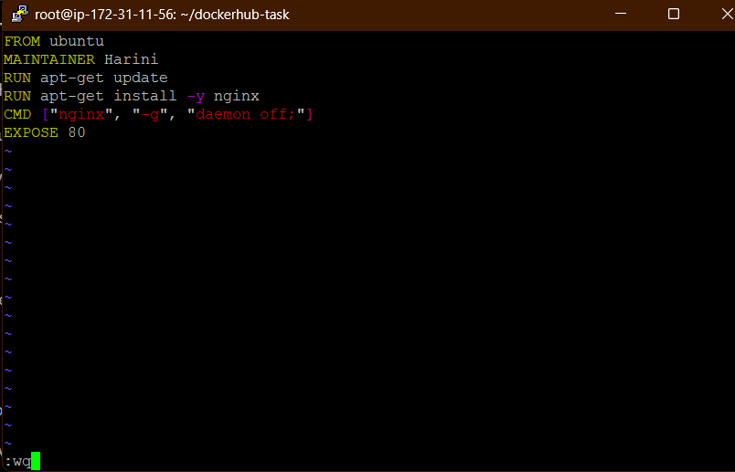
Image built:
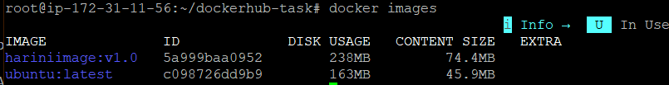
Container running:
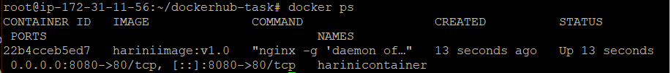
Ngnix running successfully:
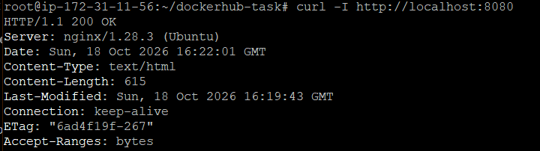

Logged in to docker:
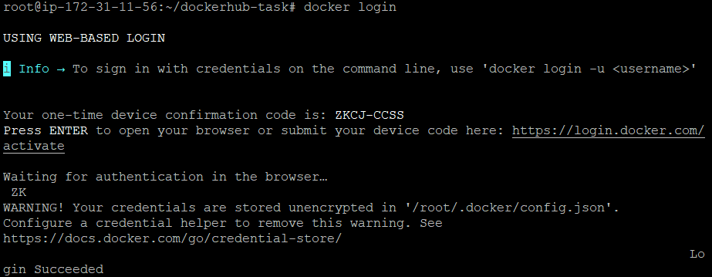Image tagged:
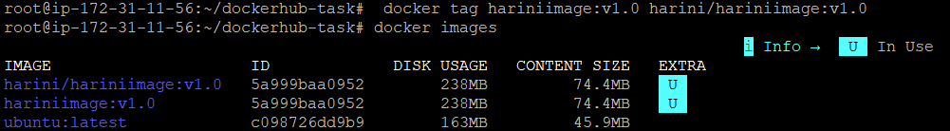
Image pushed to repository:
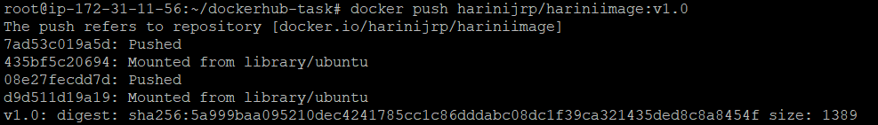
Image can be pulled:
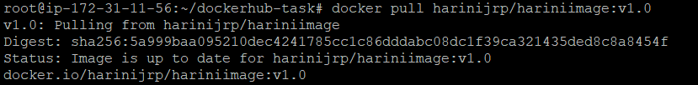
Running a container using the image:

Ngnix Running successfully in another container also:
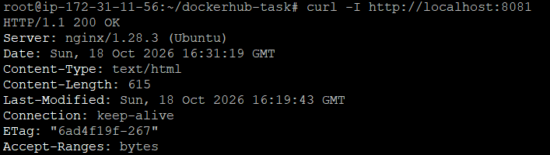
Results reflected in docker also:
